

pIWIK PRO SHAREPOINT analytics – page tracking SETUP

Version 3.0.1

Contents

1. Introduction 2

1.1. Purpose of this document 3

2. Page tracking 3

2.1. Enable page tracking 3

2.2. Disable page tracking 5

2.3. Site status 6

2.4. Manage Piwik PRO tracking properties 7

2.4.1. Site Collection Settings tab 7

2.4.2. Global Settings tab 8

2.4.3. Connection Settings tab 9

|  |  |  |  |
| --- | --- | --- | --- |
| **Date** | **Version** | **Author** | **Description** |
| 07.05.2020 | 1.0 | Ł. Kołodziejczak, N. Kozłowska,  P. Hawrylak | Document creation |
|  |  |  |  |
|  |  |  |  |
|  |  |  |  |
|  |  |  |  |

# Introduction

## Purpose of this document

The document describes how to set up site tracking by Piwik PRO SharePoint Analytics. This manual is for Site Collection Administrators.

# Page tracking

## Enable page tracking

1. Log in to SharePoint and navigate to site collection that should have tracking enabled.
2. Click the Settings wheel in the menu bar.
3. Select Piwik PRO Settings.

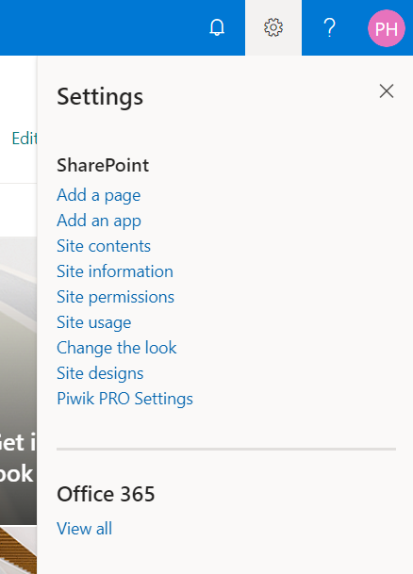

1. Enable tracking in Site Collection Settings tab.

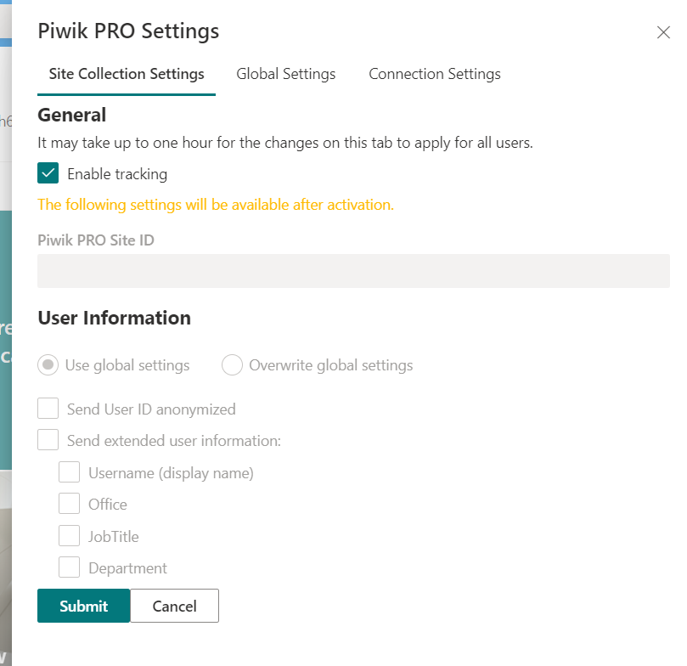

It may take up to 30 minutes to activate - it depends on the SharePoint Search crawl. Other options will be available after activation. Tracker settings are cached for 1 hour in browser, so tracking may not be enabled for some users until cache expiration.

1. To check if tracking is active, open Piwik PRO Settings again. If User Information options are available, site is activated.
2. You can also check activation status in Piwik PRO Administration site (URL: <SHAREPOINT_URL>/sites/PiwikAdmin) -> Site contents -> Piwik PRO Site Directory list.
3. If the status is “Active” the site tracking has been fully activated.

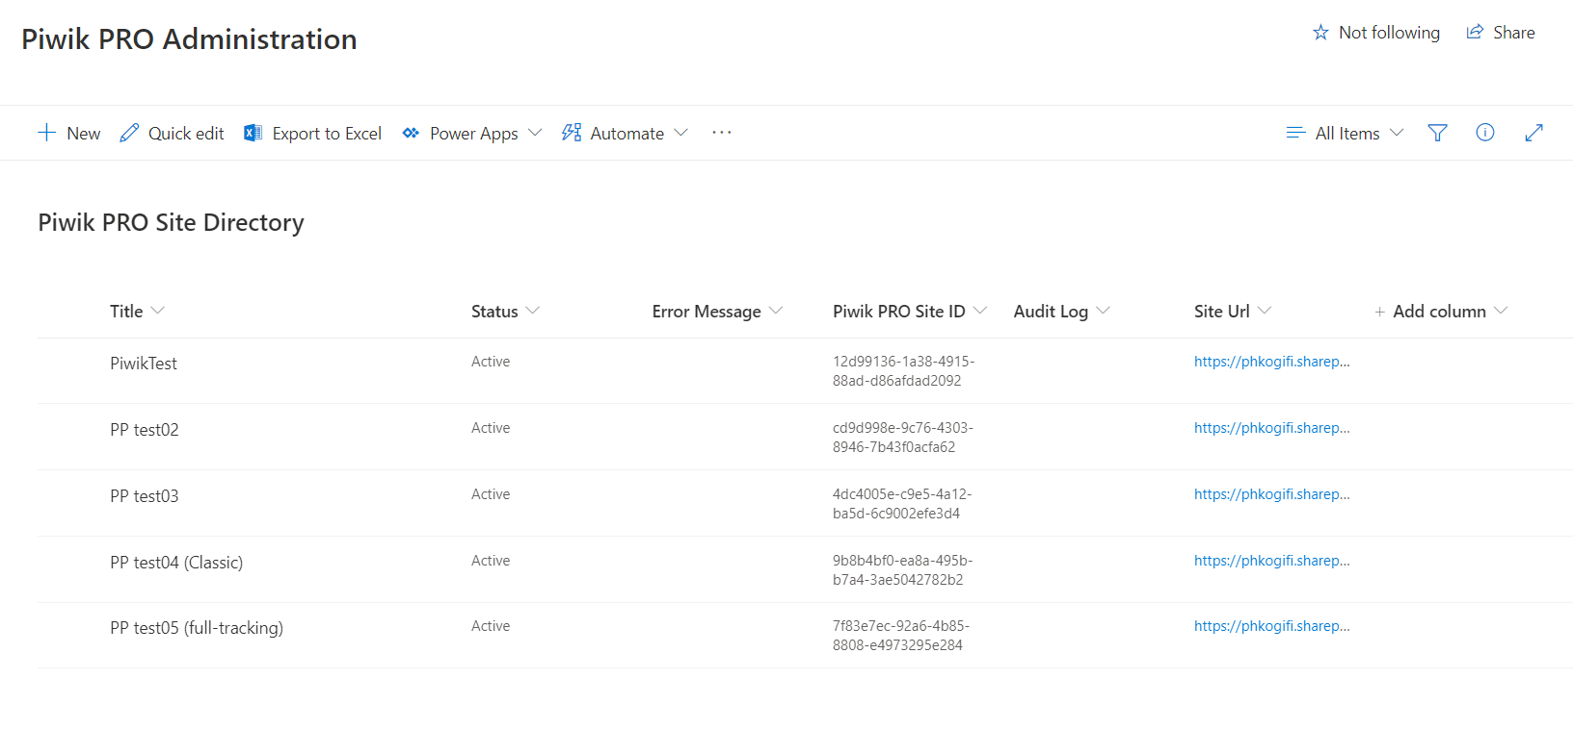

## Disable page tracking

1. Log in to SharePoint and navigate to site collection that should have tracking disabled.
2. Click the Settings wheel in the menu bar.
3. Select Piwik PRO Settings.



1. Disable tracking by deselecting "Enable tracking" in Site Collection Settings tab.

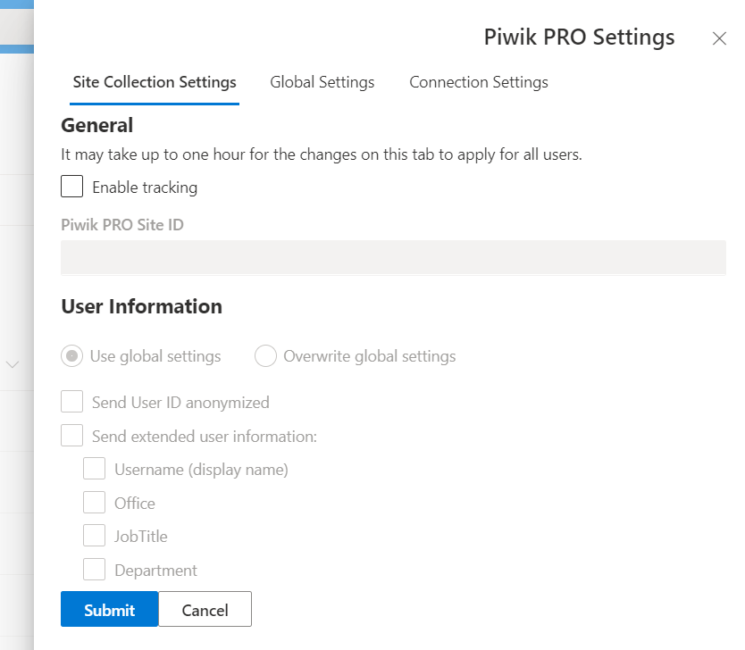

1. If you want to check if tracking is disabled, navigate to Piwik PRO Administration site (URL: <SHAREPOINT_URL>/sites/PiwikAdmin) -> Site contents -> Piwik PRO Site Directory list.
2. If the status is “No Active” the site tracking has been fully deactivated.

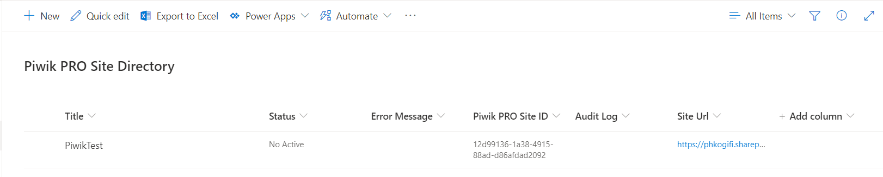

## Site status

Status is visible on Piwik PRO Site Directory list on Piwik PRO Administration site and informs if the page is tracked by Piwik PRO.

|  |  |
| --- | --- |
| **Site Status** | **Definition** |
| New | The site is not tracked by Piwik PRO yet. Site was activated in Piwik PRO Settings and appeared on Piwik PRO Site Directory list on Piwik PRO Admin site. The scheduled job process is reading the list and activating entries with "New" status. |
| Active | The site is tracked by Piwik PRO. |
| Deactivating | The site is still tracked by Piwik PRO. The site was deactivated in Piwik PRO Settings. The scheduled job process is reading the list and deactivating entries with "Deactivating" status. |
| No Active | The site isn’t tracked by Piwik PRO but it used to be in the past. |
| Deleted | The site was tracked by Piwik PRO but it was deleted. |

## Manage Piwik PRO tracking properties

1. Piwik PRO Settings are available in every site in the Settings menu. It is visible only to Site Collection Administrators.



1. After clicking on it, the settings panel will be displayed.

### Site Collection Settings tab

Site Collection Settings tab is visible only to Site Collection Administrators.

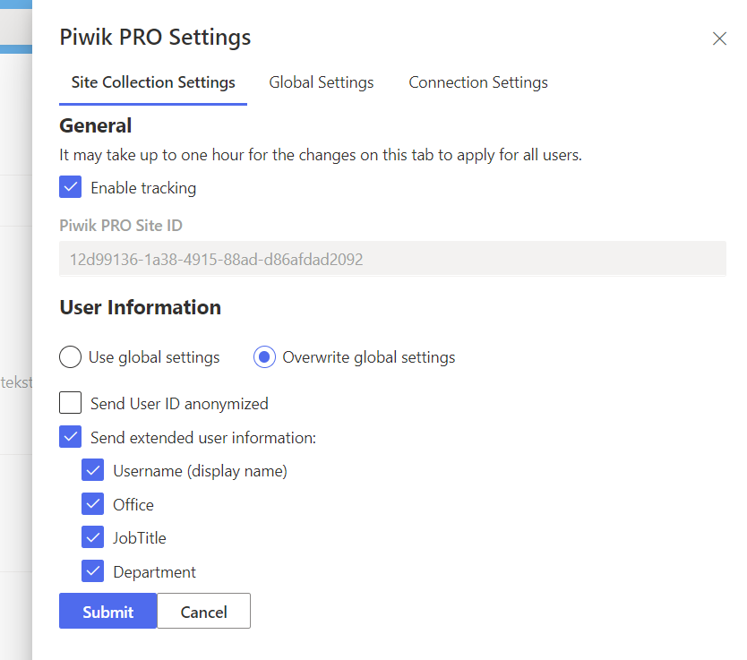

Form fields:

* Enable tracking – enables tracking on a site collection
* Piwik PRO Site ID – ID generated by Piwik PRO for this site collection, read-only
* User information:
  + Use global settings/Overwrite global settings – controls if global settings are overwritten.
  + Send User ID anonymized - every user is still identified uniquely but their identity is hidden for privacy.
  + Send extended user information - check if extended user data needs to be tracked.
  + Username (display name) - tracks user's UserName as Analytics Custom Dimension.
  + Office - tracks the user's Office as an Analytics Custom Dimension.
  + JobTitle – user's job title will be visible in tracking information.
  + Department - tracks the user's Department as an Analytics Custom Dimension.

### Global Settings tab

Global Settingstab is visible only to Piwik PRO Administration site collection administrators.

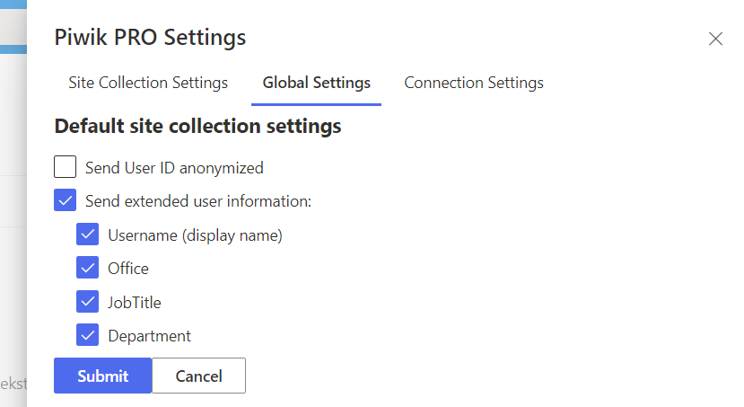

Default site collection settings - default values for User information settings. When site collection admin activates the Piwik PRO Analytics Suite integration on a new site collection, these settings will be used unless they are overwritten.

### Connection Settings tab

The Connection Settingstab is visible only to Piwik PRO Administration site collection administrators.

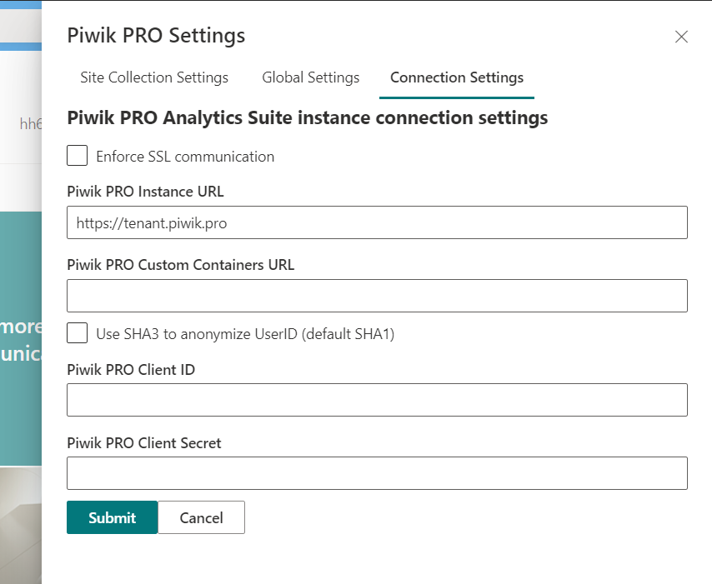

Form fields:

* Enforce SSL Communication - if Piwik PRO is locally installed with SSL, enable SSL Communication.
* Piwik PRO Instance URL (required) – full URL to your Piwik PRO instance.
* Piwik PRO Custom Containers URL (optional) – full URL to custom containers (if needed).
* Use SHA3 to anonymize UserID (default SHA1) – the previous version of Piwik PRO SharePoint Analytics used SHA1 algorithm. When you switch from SHA1 to SHA3 users will be encrypted all over again. Each user will receive a new hash. Matching between old hash encrypted by SHA1 and new hash encrypted by SHA3 will not be possible. Historical data will be encrypted by SHA1.
* Piwik PRO Client ID - generated on Piwik PRO page> Piwik PRO page > User Panel > API credentials > Generate new credentials.
* Piwik PRO Client Secret - generated on Piwik PRO page> Piwik PRO page > User Panel > API credentials > Generate new credentials.